H1 - Selective sampling bouts and odor
Do sampling bouts coincide with elevated odor? (Selective Sampling-Bout analysis, reactions_2)
Result: H1 is NOT supported. Peri-bout baseline-subtracted ethanol (median 0.0137 a.u.) is LOWER than the matched within-trial random-time null (median 0.0291 a.u.; delta = -0.0154 a.u., ~53% below null), and is not greater than incidental-event peri-odor. Sampling bouts are not accompanied by elevated odor.

1. Goal and hypotheses
A sampling bout is a rare, deliberate event defined by a locomotor pause plus a head cast (a translation-invariant head-body bearing angular speed, omega). This report tests whether such bouts - not incidental head motion - coincide with elevated odor at the head.
H1 (directional): peri-bout baseline-subtracted ethanol exceeds BOTH (a) a matched within-trial random-time null AND (b) incidental-event peri-odor. Accept only if both hold.
H0: peri-bout ethanol equals the matched random-time null and does not exceed the incidental-event peri-odor.

2. Methods
Data were read through the project accessor only and processed with the shared library code/reactions2_common.py (which reuses reactions/code/reactions_common.py; no science re-implemented). All computation used the pinned interpreter (vras/Scripts/python.exe), headless matplotlib (Agg), fixed seed 1234.
Replication unit is the TRIAL (one statistic per trial), pooling Loc1-6 (n = 105 trials); anotherLoc (n = 9) is held separate. Only trials with at least one bout contribute to the bout-conditioned tests.
Bout detector (final parameters, D6 rarity gate PASSES; not loosened, d6_tightened = False): v_pause = 5.89 px/s (25th pct of pooled COM speed), tau_pause = 0.30 s, dphi_min = 40 deg, omega_min = 156.6 deg/s (90th pct of pooled omega), t_merge = 0.50 s. Achieved pooled median bout rate = 0.00733 /s (~232x rarer than the v1 baseline of 1.7 /s).
Odor signal: baseline-subtracted ethanol on the raw scale (raw minus a rolling 10th-percentile, 20 s window), on the head clock. Peri-odor per event is the mean baseline-subtracted ethanol in [-0.5, +0.5] s around bout onset. The H1 null is a matched-count random-time permutation drawn within the same trial. Inference is trial-level Wilcoxon (never per-event point-bootstrap); trial-bootstrap CIs use 2000 draws (permutation null 2000 draws), seed 1234. No family-wise correction; per-test CIs.

3. Results
Magnitude and direction first (the p-value is secondary). Per contributing trial, the median peri-bout ethanol is 0.0137 a.u. (trial-bootstrap mean 0.0240 a.u., 95% CI [0.0156, 0.0348]). The matched within-trial random-time null has a median of 0.0291 a.u. - so the observed peri-bout odor is actually LOWER than chance by -0.0154 a.u. (~53% below null). The direction is opposite to H1.
(a) Bout vs matched null: the trial-level Wilcoxon test of bout > null gives p = 0.9998 (one-sided; stat = 231.0, n = 46 contributing trials) - i.e., no evidence that peri-bout ethanol exceeds the null; the direction is against it.
(b) Specificity vs incidental events: peri-bout ethanol (median 0.0137 a.u.) is not greater than incidental-event peri-odor (median 0.0256 a.u.); Wilcoxon bout > incidental p = 0.9948 (stat = 309.0, n = 46).
Absolute-amplitude check (necessary, not sufficient). Peri-bout ethanol does sit above the instrument noise floor (~0.0004 a.u.) relative to the full range (~0.14 a.u.): 60.5% of bouts have peri-odor > 0.01 a.u. (above_floor = True). But above-floor is necessary, not sufficient - the inferential comparison against the matched null is the deciding test, and it is null / negative. Both acceptance conditions fail, so H1 is rejected (accept_H1 = False).

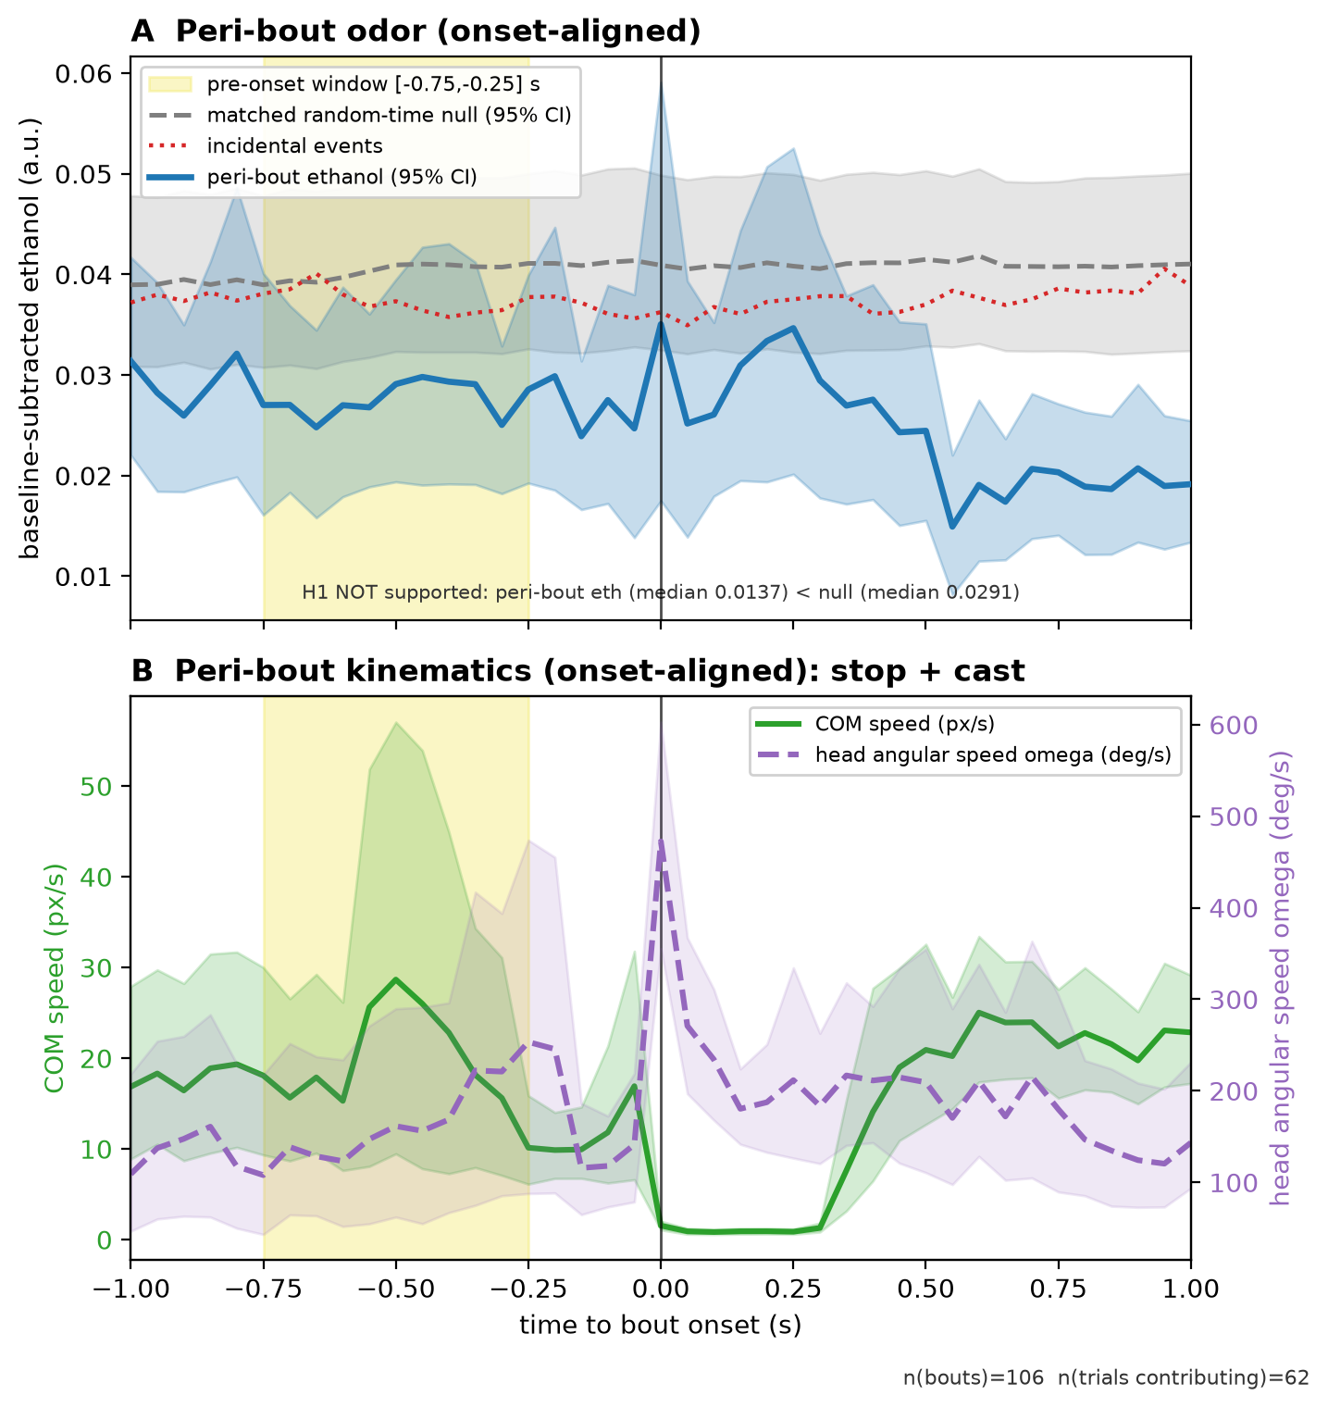
Figure F2. Onset-aligned peri-bout signals (pooled Loc1-6; n(bouts) = 106, n(trials contributing) = 62; vertical line at bout onset, t = 0). (A) Mean peri-bout baseline-subtracted ethanol (a.u.) with 95% trial-bootstrap CI (blue), overlaid on the matched random-time null (grey dashed, 95% CI) and the incidental-event curve (red dotted); the shaded band marks the pre-onset window [-0.75, -0.25] s used by H2. The bout curve lies at or below both comparators throughout - peri-bout odor is not elevated. (B) Mean peri-bout COM speed (px/s, left axis) and head angular speed omega (deg/s, right axis), showing the locomotor stop at onset accompanied by the head cast. Shared with the H2 report.

3.1 Key numbers
Quantity | Value
Median peri-bout ethanol (a.u.) | 0.0137
Peri-bout mean, 95% CI (a.u.) | 0.0240 [0.0156, 0.0348]
Median matched random-time null (a.u.) | 0.0291
Delta (observed - null) (a.u.) | -0.0154
Wilcoxon bout > null, p (one-sided) | 0.9998
Median incidental-event peri-odor (a.u.) | 0.0256
Wilcoxon bout > incidental, p (one-sided) | 0.9948
Fraction of bouts with peri-odor > 0.01 a.u. | 0.605
Above noise floor? | True
Contributing trials (bout-conditioned tests) | 46
Accept H1? | False

4. Caveats
Modest N and sensor coverage. Only 46 of the 105 pooled trials contribute to the bout-conditioned tests: bouts are deliberately rare (achieved median rate 0.00733 /s) and some bout onsets fall outside ethanol-sensor coverage (NaN odor), so they cannot be scored. This limits statistical power; the negative result should be read as 'no detectable elevation at this N', not proof of exact zero.
Above-floor is not sufficient. That most bouts sit above the noise floor tells us the signal is measurable, not that it is elevated relative to chance; the matched-null test is what adjudicates the odor claim, and it is null / negative.
Single cohort, pixel units. Results are from one pooled cohort (Loc1-6); anotherLoc is held separate. Kinematics are reported in raw pixel and pixel/s units (no metric calibration applied), and ethanol is on the raw baseline-subtracted scale.

5. Reproducibility
Objects: data/stats.json (H1 block, figure_curves_meta) and data/bouts.h5 (/figure_curves/F2A_*, /figure_curves/F2B_*). Library version reactions2_common/1.0, created 2026-08-09T00:23:28Z (UTC), seed 1234, odor cutoff 0.001. Figure and report inject numbers from these objects; nothing is hardcoded.
Rebuild: "%AR_PY%" code\build_F2.py ; "%AR_PY%" code\build_H1_report.py (with AR_PY = the pinned vras interpreter). Outputs: reports\figures\F2_peri_bout.{png,pdf,txt} and reports\H1 - sampling bouts and odor.docx.

